Building your Allocated Component
Your Git Hub day

Building your Allocated Component 1
Before you Begin 1
Revisit your System Specifications 1
Copy and Adapt 1
So where do we go next? 1
The GitHub Workflow 2
Create a clean folder for this work cycle 3
Clone the repository to the folder 4
Create a new branch (Don’t edit the master directly) 8
Do some work on your part of the system 12
Save your work 18
Scan for changes 19
Add notes 20
Commit changes 20
Sync 20
Go to Git 21
Create a new pull request (complete the process with appropriate comments from another team member) 22
Delete branch 24
Delete the local folder you created at the start of the day 24

Building your Allocated Component

Before you Begin
Make sure that you have completed the work for last week and that you have watched the eLectures for this week before starting this work.

Revisit your System Specifications
Remember at the start of the module you created system specifications identifying what your application is going to do and who is allocated which section?
Now is the time to return to these documents to remind you of who is working on what component.
I will continue to use my address book examples but remember you don’t simply copy my examples, you need to copy and adapt such that it meets your personal requirements.

Copy and Adapt
One approach we will use to introduce programming concepts is copy and adapt.
The idea is that I present you with an example from my own design and then you need to adapt that design to match your own requirements.
For example, if you are creating a system to manage staff you need to look at my address book code and adapt it such that it follow your own requirements not mine. If I say clsAddress you need to create clsStaff etc..

So where do we go next?
We will implement the class pair clsAddressCollection and clsAddress
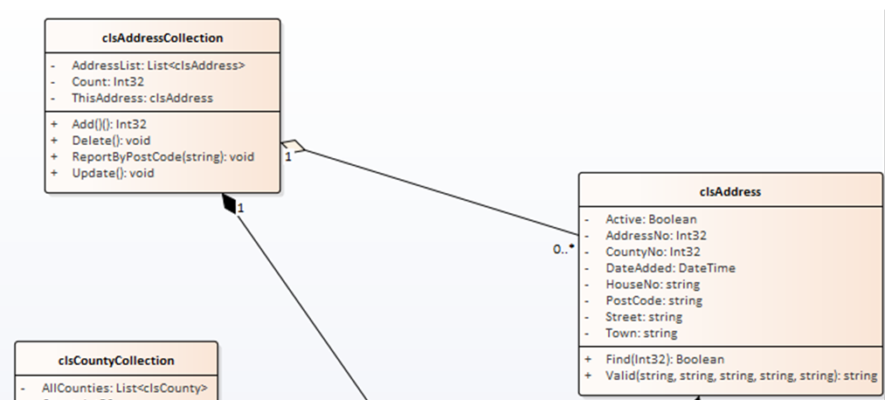
As above let’s start with something simple. Since clsAddressCollection uses clsAddress we will start with clsAddress.
The problem we have now is that via GitHub you will all be working on your systems as a team so we need to establish a work flow such that you don’t keep treading on each other’s toes.

The GitHub Workflow
Here is a quick check list of the GitHub workflow we will use as you work together...
Initial Setup (You should all have done this by now!)
- Set up the local skeleton system for the team project containing one class library, one test project a customer facing front end and a staff facing back end
- Make sure this compiles and the folder structure is correct
- As a team select one person to host the master repository on GitHub
- Invite team members to collaborate
- Add the local system skeleton to source control such that the code is in the master repository
- Each member should test that they are able to make a clone of the skeleton system and that the folder structure is identical for each team member
- Remember – the master repository is sacred do not edit directly
The next stage is to forget that you are a student and start thinking like an employed software developer.
Imagine now that you work within a company, clock in at nine o’clock and leave at five.
At 9am you start the working day
- Create a clean folder for today’s work cycle
- Clone the repository to the folder
- Create a new branch (NEVER edit the master directly)
- Do some work on your part of the system
At 5pm you finish the working day
- Save work
- Scan for changes
- Add notes
- Commit changes
- Sync
- Push
- Go to Git
- Create a new pull request (complete the process with appropriate comments from another team member)
- Delete branch
- Delete the local folder you created at the start of the day
IMPORTANT!
When you are working on code within your own local branch, that code is unavailable to other members of your team until you have pulled the changes into the master branch.
There are two issues to think about here.
- Never put code into the master that is buggy or doesn’t compile, this is a really good way of spreading bad code to your team members
- Keep the life of your branches short. What I mean is complete a small section of work, say create a few tests with corresponding changes to the class library then merge the new code with the master once you are confident it is debugged and free of compilation errors.
- 24 hours is a long time in Git. The longer you sit on code in your own branch the longer other team members have to wait to access your code.
- Always talk to each other! Let each other know what work you are about to undertake such that you may anticipate any potential problems.
As above, we will start with the most basic test i.e. creating an instance of the required class. This time we will do it within the context of the GitHub work flow.

Create a clean folder for this work cycle
This should be the easy bit. When starting this cycle of work you must not start working on an old copy of your work, why? While you have not been working it is likely that other team members have made changes to the system. If this is potentially the case then you must start with a clean copy of the system, so best to clone this to a new empty folder. I tend to like to create my own so I know where it is the file system like so...
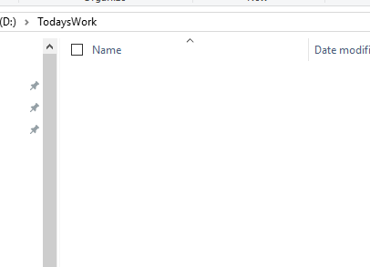

Clone the repository to the folder
To clone the master repository you will need to know the URL of the repository.
This is available from the repository under Clone or Download...
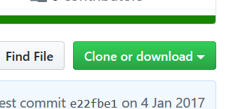
Like so...
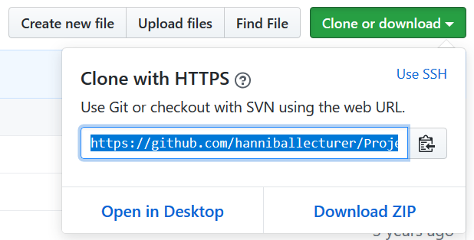
You will need to then start Visual Studio.
Once Visual Studio is open you will need to access the Team Explorer on the right of the interface...
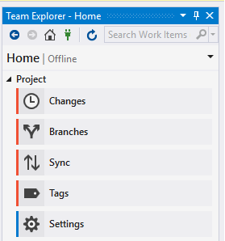
To clone the repository you need to connect to GitHub using the green connect icon...

From here, select the option for cloning the repository...
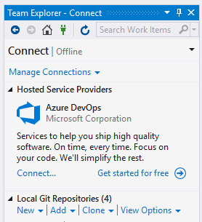
Enter the URL of the repository along with the path of the folder you plan to work in...
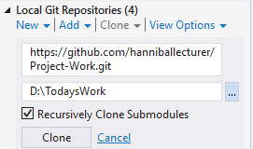
Then press Clone.
After a little while you should see the solution listed in Team Explorer...
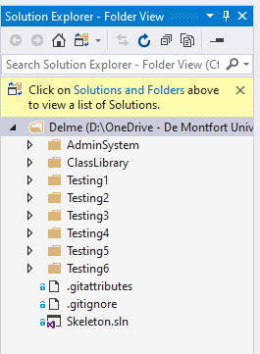
Also if you look at the folder for today’s work you will see that the files have been cloned to the local PC...
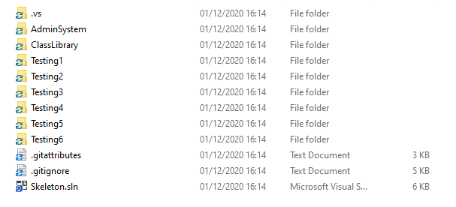
To open the solution, double click the solution file in Visual Studio...
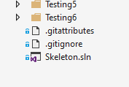
You should now see all projects listed in the solution explorer...
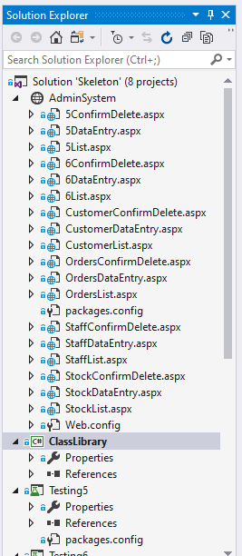

Create a new branch (Don’t edit the master directly)
As things stand you have a copy of the master repository, if you edit this you will be directly editing the system and potentially create problems for your team members.
The only time you edit the master repository directly is for high level admin operations ensuring that there are no active branches open on the work.
To do today’s work you need to create a new branch for yourself to isolate your changes from the code belonging to other members.
In Visual Studio under Team Explorer select home and then branches...
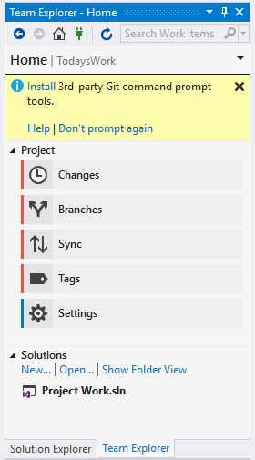
You should see on the next screen that the master branch is selected...
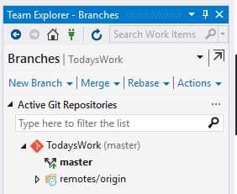
Right click on the master branch and select “new local branch from...”
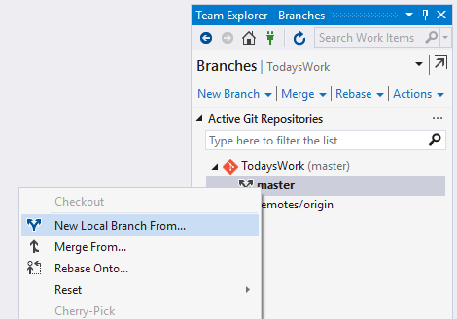
Click this option and enter a name for your local branch...
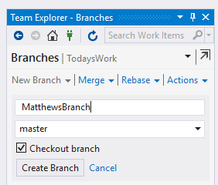
Next select “Create Branch”.
To create the branch on GitHub you also need to push the branch to the remote server.
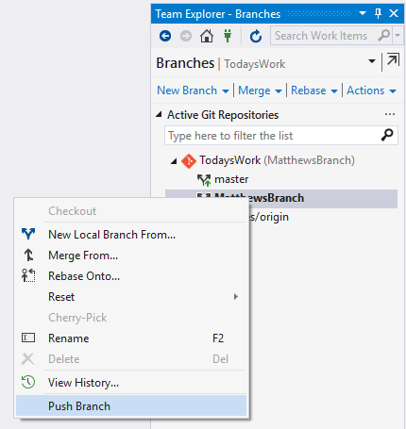
Visual Studio is likely to ask for your GitHub user name and password.
The branch has now been created locally and also on the server, this way your other team members know that you are working on something.
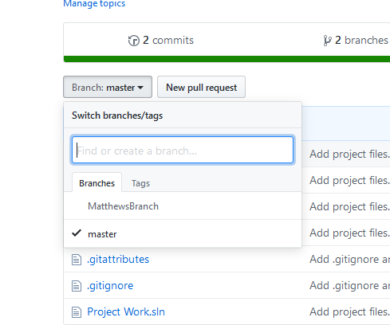

Do some work on your part of the system
Let’s create a test class.
I am going to claim section 6 as my allocated part of the system. I plan to create an address book of clients.
So, I will rename section 6 to the following…
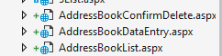
And my test project like so…
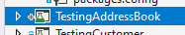
Clearly you should have done this part when your SCRUM master set up the master repo.
You need to copy and adapt my examples from now on and apply them to your part of the system.
To create my first test class, I need to right click on my test project and add a new test.
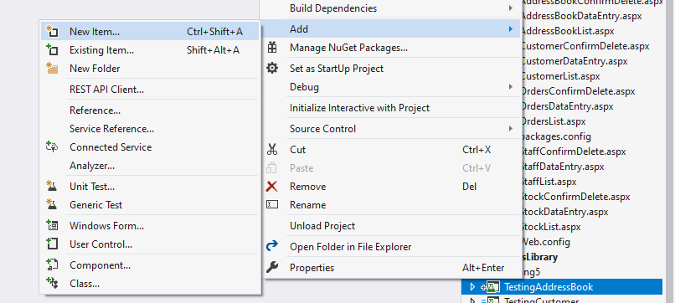
I need to locate Basic Unit Test under the test section of the templates…
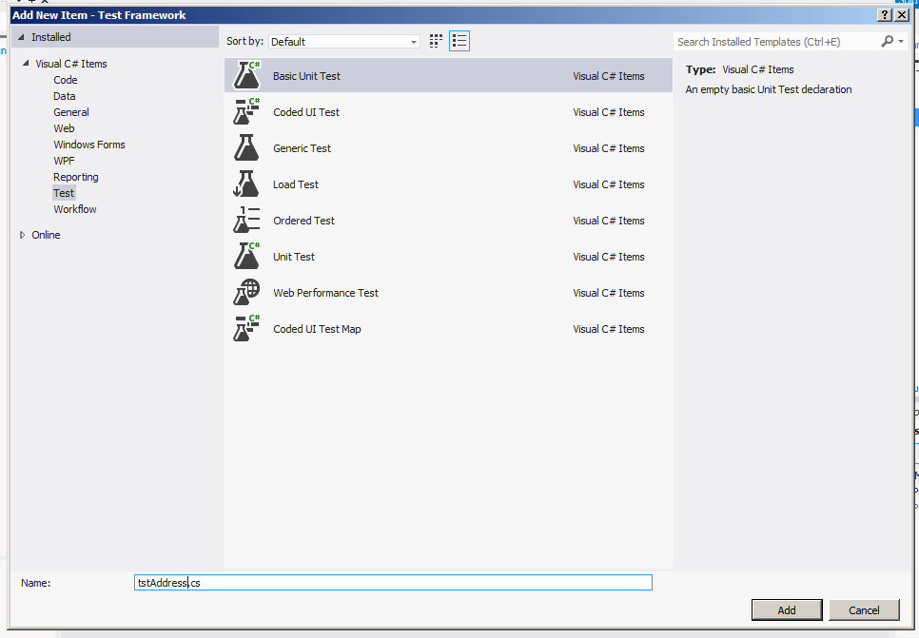
In this example I am creating a test to test another class.
The class I am really interested in is going to be called clsAddress and will be stored in my class library.
To make clsAddress I will create a test class called tstAddress, note the naming convention. tstAddress will be stored in my test project TestingAddressBook.
You need to adapt this to your own component. If you are working on staff management you would create tstStaff, if you are working on stock, tstStock etc.
When the test has been created you should see something like this on the screen…
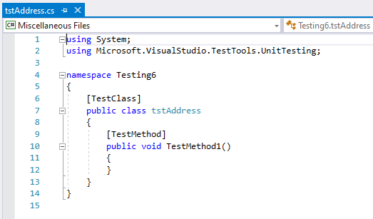
(The namespace will vary depending on your allocated component, don’t change this.)
The first test we need to create is the test for instantiating a new object based on clsAddress.
So next we create the test for instantiation…
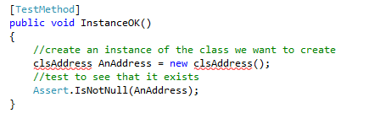
The code for the class should look like this…
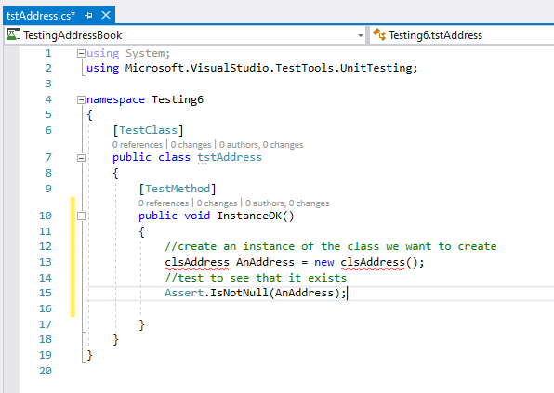
To run the test you will need to select the test option from the main menu…
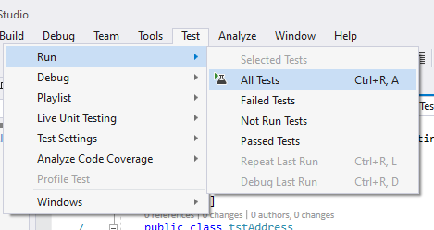
Given that clsAddress doesn’t exist (as indicated by the red underlining) the test should fail.
Like so…
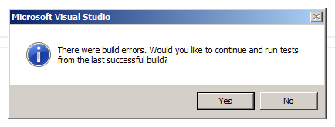
(Always, always, always, always, always, always, always, always, always, always, always, always, always, always, always, always, always, always, always, always, always, always, always, press NO when you see this message!)
To fix the problem we need to create the class file.
Hold the mouse over the red underlining and wait for the following menu to appear…
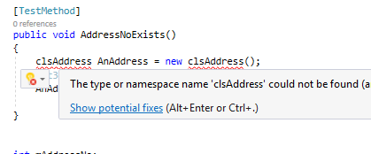
Click on “Show potential fixes” and these options should appear.
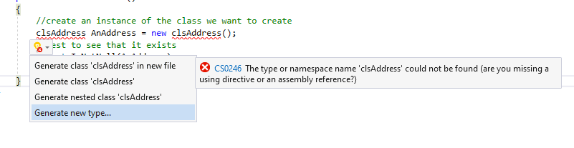
Select generate new type and you should see the following…
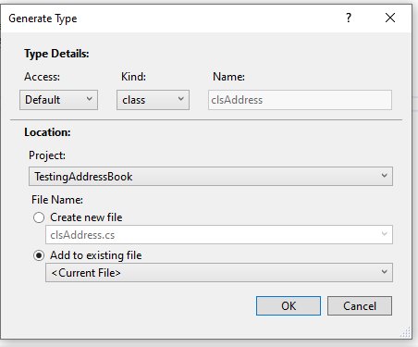
Note that the default setting on this screen are almost certainly wrong.
Change the settings like so…
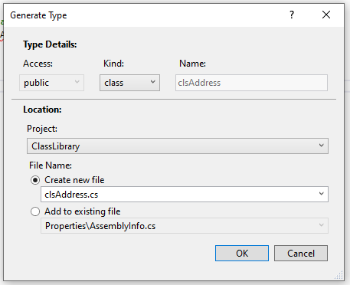
Make sure the setting are correct and that you are creating the class in your class library.
Once you press OK you should see the new class in your shared class library…
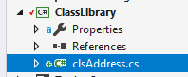
Run all test like before…
You should now see the test pass…
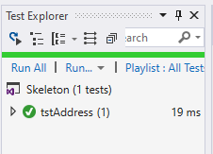
That’s enough work for one day!

Save your work
Make sure everything is saved in Visual Studio.
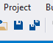

Scan for changes
From the home of Team Explorer select Changes...
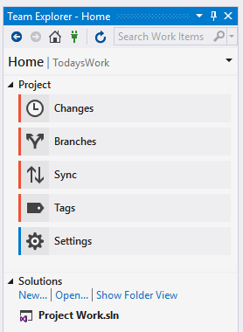
Visual Studio will look at the code you have written and should identify that there have been changes to the system like so...
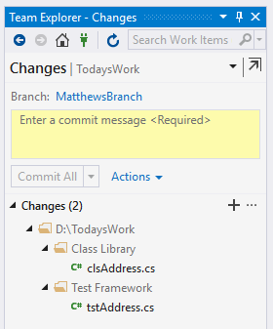

Add notes
Before you are able to do anything else you need to add some notes explaining what you have changed. The idea is that you leave a paper trail so that other people know what has been changed in the system and by whom.
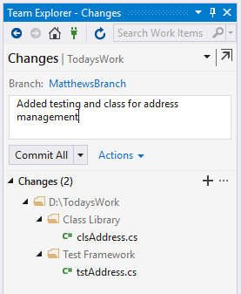

Commit changes
You should now be able to commit the changes.
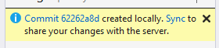
This has told the local system to accept the changes. In order for the changes to appear in GitHub you will next need to sync the changes with the server.

Sync
So far the local branch is aware of your changes, selecting Sync tells the main Git server about what you have changed.

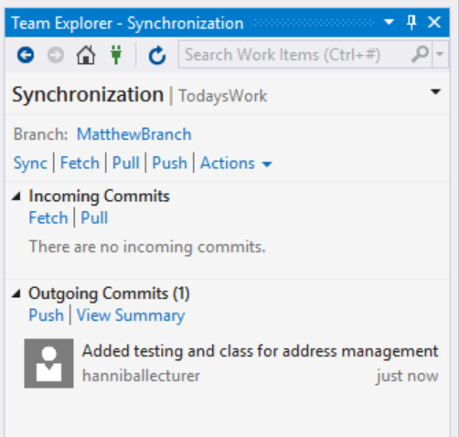
Finally push your changes to the remote repository...
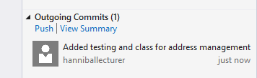

Go to Git
The next step is to check that the changes have been copied over to GitHub.
If you look at the repository you should see that the master branch and your own branch are listed...
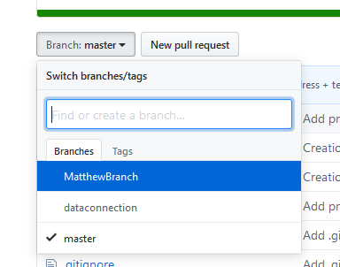
Select the new branch, not the master.
You should be able to see all of the changes listed in the repository.

Create a new pull request (complete the process with appropriate comments from another team member)
We now want to take the branch on GitHub and merge it back into the master branch, to do this we need to create a new pull request...
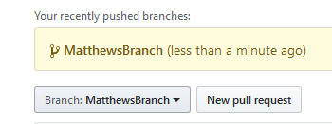
Press the button to create the pull request and you should see the following screen...
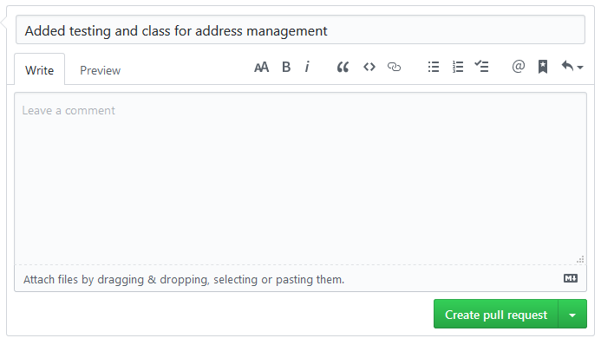
The idea here is that you ask another team member to review the changes and confirm that you are not adding bad code to the main repository. Once you are both happy you may add some comments.
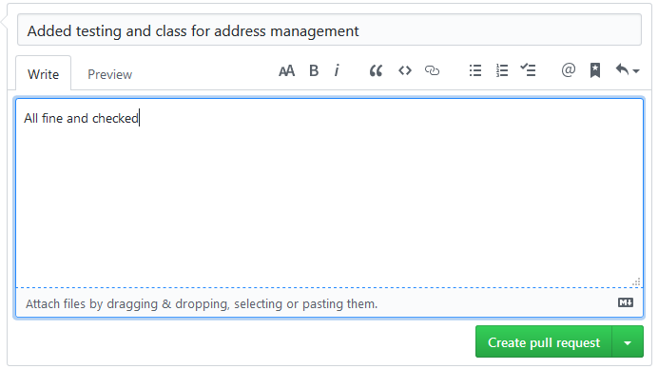
The select create pull request.
GitHub will check to see if there are any conflicts, hopefully not...
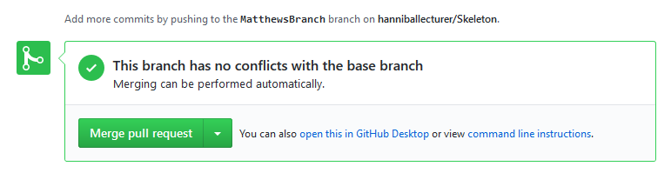
If there are conflicts you will have to resolve them (this is where the fun begins and why it is good to talk to each other!)
If all is well, select merge pull request followed by confirm merge (you have to really mean it!)
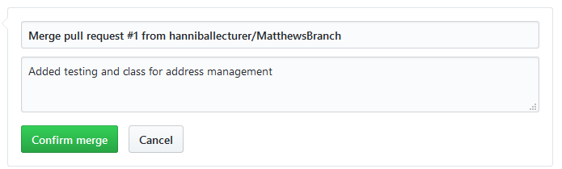

Delete branch
Once the pull request is completed you need to delete your branch...
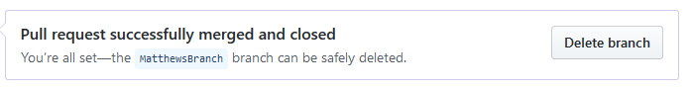

Delete the local folder you created at the start of the day
I would also suggest that you tidy up your local machine by deleting or archiving your local folder.

